**Hamna Qasim 55194**

**Web App Development Lab # 5**

**Tasks**

**Task1:**

let arr=[1,2,3,4,5];

for(let even of arr)

{

    if(even%2==0)

    {

        console.log(even);

    }

}



**Task2:**

let arr=[2,3,4,5,6,7,8,-10,-4,-5];

let min=arrr[0];

let max=arrr[0];

for(let num of arr)

{

    if(num<min)

    {

        min=num;

    }

    if(num>max)

    {

        max=num;

    }

}

console.log("Minimum= "+min);

console.log("Maximum= "+max);



**Task3:**

let heroes=["black widow", "thor", "ironman"];

for(let entry of heroes)

{

    console.log(entry.toUpperCase());

}

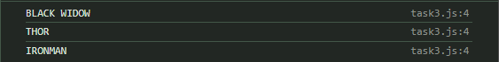

**Task4:**

let arr=["DPL","Tekrowe","Tenergy","Netline"];

console.log(arr);

console.log("Removing first Element");

arr.shift();

for(let sw of arr)

{

    console.log(sw);

}

console.log(arr);

console.log("Removing middle Element and adding another");

arr.splice(1,1,"SiliconeV");

for(let sw of arr)

{

    console.log(sw);

}

console.log(arr);

console.log("adding at the end");

arr.push("Google");

for(let sw of arr)

{

    console.log(sw);

}

console.log(arr);

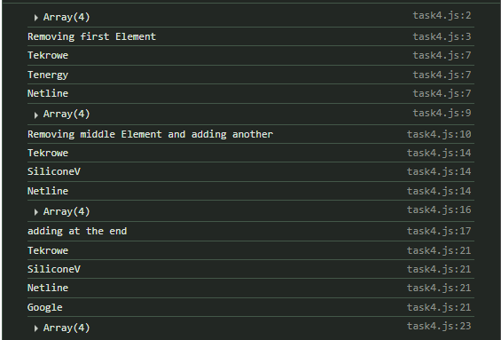

**Task5:**

function vowels(str) {

    let ccount = 0;

    for (let char of str) {

        if (char == 'a' || char == 'e' || char == 'i' || char == 'o' || char == 'u' ||

            char == 'A' || char == 'E' || char == 'I' || char == 'O' || char == 'U')

        {

            ccount++;

        }

    }

    return ccount;

}

let vnum = vowels("abracadabra");

console.log("Number of vowels= " + vnum);



**Task6:**

const vowels = (str) => {

    let ccount = 0;

    for (let char of str) {

        if (char == 'a' || char == 'e' || char == 'i' || char == 'o' || char == 'u' ||

            char == 'A' || char == 'E' || char == 'I' || char == 'O' || char == 'U')

        {

            ccount++;

        }

    }

    return ccount;

};

let vnum = vowels("abracadabra");

console.log("Number of vowels= " + vnum);



**Task7:**

let arr = [1,2,3,4,5,6,7];

console.log(arr);

console.log("squares= ");

arr.forEach(function square(num)

{

    console.log(num * num);

});

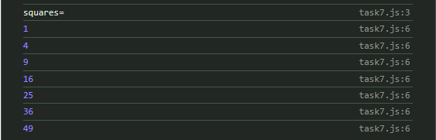

**Task8:**

let marks=[70,80,55,60,67,89];

console.log(marks);

let fiftyabove=marks.filter((above) =>

{

    return above>50;

});

console.log("50 above marks are= ",fiftyabove);



**Task9:**

let x=prompt("Enter a number= ");

let arr=[];

for(let i=1;i<=x;i++)

{

    arr.push(i);

}

console.log(arr);



**Task10:**

let arr = [1,2,3,4,5,6,7,8,9,10];

console.log(arr);

const prod = arr.reduce((res, curr) => res * curr);

console.log("Product of array", prod);

